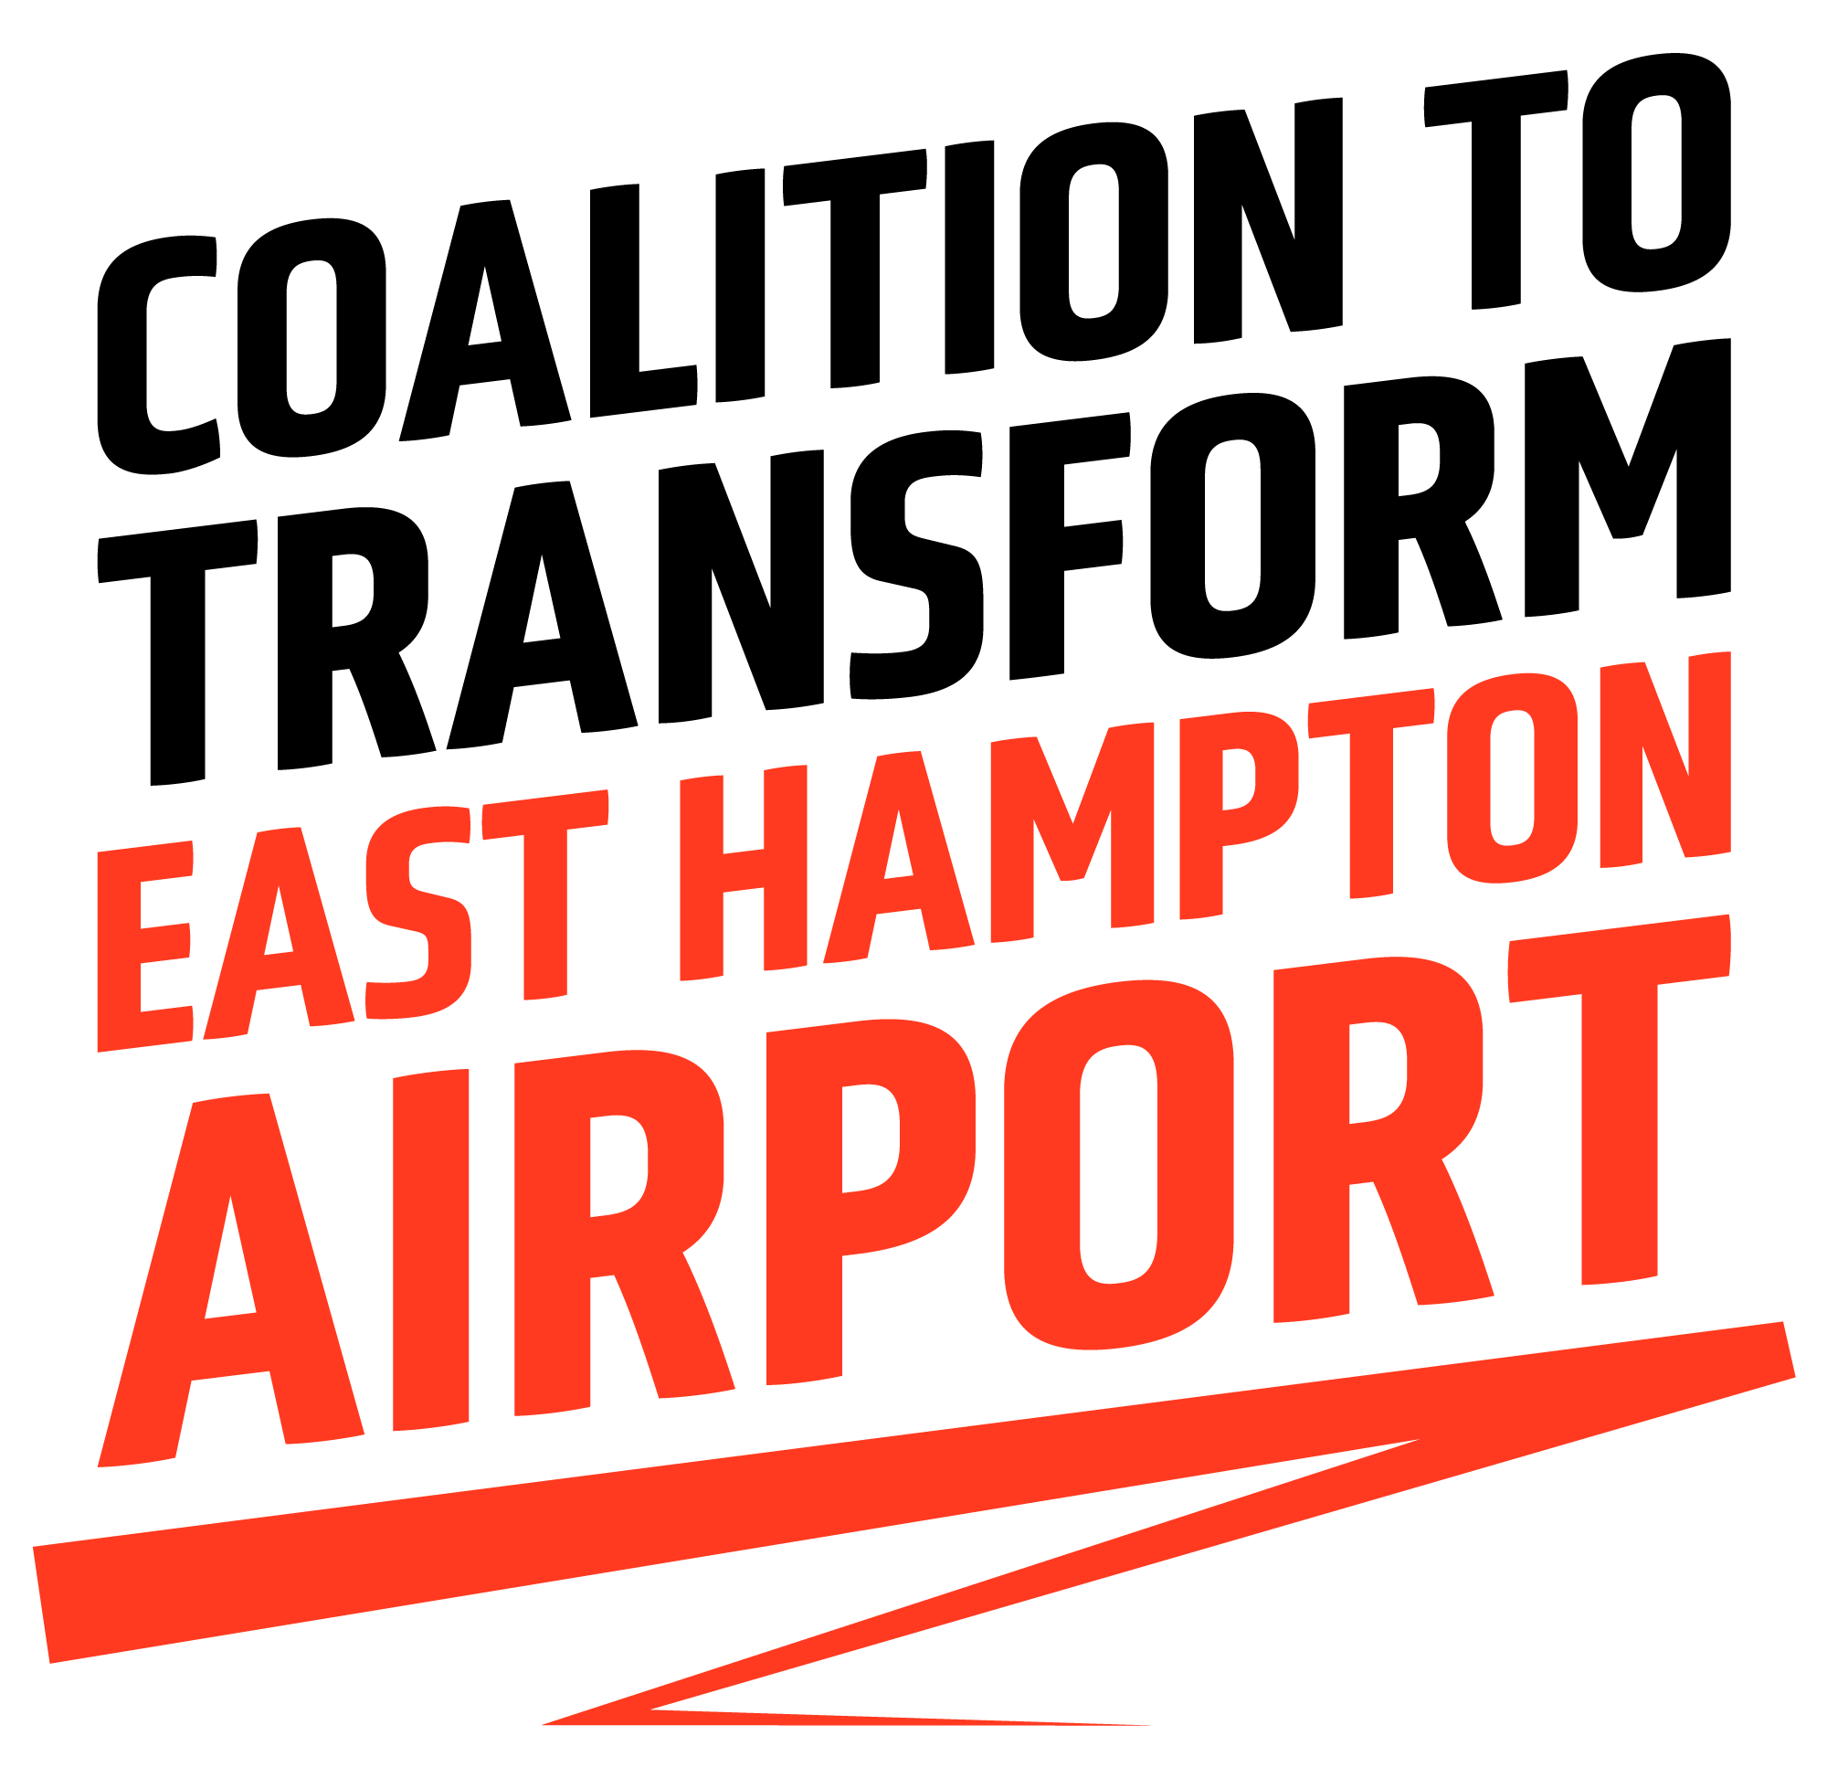
TO: East Hampton Town Board
FROM: [enter your name and town]
RE: East Hampton Airport Re-Envisioning Workshop
DATE: September [enter date], 2021
As the Town Board continues to deliberate and hear testimony regarding the fate of the East Hampton, I write this letter as a concerned resident and community member.

As you, my fellow East Enders, know all too well, the air traffic coming through East Hampton Airport (KHTO) has been a quality of life and environmental blight on our region for decades. Now, for the first time in 20 years, this Town Board, on the behalf of the 99% percent of us who do not use the airport, can ground the airport forever. We cannot afford to miss this opportunity to shut it down for good--and reimagine it as a place that serves and protects the entire community.

Whether it is used for a nature preserve, safe hiking trails (no cars!), athletic fields, outdoor grass-terraced amphitheater, safe biking trails and loops, safe running trails, art galleries in place of aircraft hangars and more -- there’s certainly enough space for us to dream big about a use that actually adds value to our town rather than damaging it.

The Town Board’s own commissioned reports have concluded the economic contribution from the airport is minimal at best, and there are substantial quality of life and environmental benefits to shutting it down. Make no mistake, allowing this airport to continue operating would be to continue subsidizing the destruction of the environment around us.

My family and I implore you to listen to us, the people who live here and call this place home, and ignore those who only stand to continue to profit by taking advantage of our town.

For the first time in 20 years, we the people of East Hampton have a say in the future not just of the East Hampton Airport, but of our skies, the air we breathe, and the water we drink. I am writing this letter to add my voice to the chorus of thousands of my East End friends and neighbors -- KHTO must go.

Sincerely,

[Your name]
Address (or part of town)

